QUESTIONS:
- How would you assist the Martinez family in meeting their health and nutrition needs?
- Describe five (5) potential nutrition problems, and at least one question per potential problem you might ask the family to assess their nutritional intake and status (10 points) and
The first problem is that the family risks obesity since eating of French fries increase the incidence of being being obese.
    - The question for this problem is; do you as a family wish to have be overweight?
The other problem is that, the immunity of the members of the family is likely to deteriorate since they do not take enough vitamins.
    - The question to them members will be if, what ways will they think they will be able to improve their diet?
The third problem will be the likelihood that Mi Yona and Derrick will suffer from kwashiorkor.
    - The question will be, whether the family will be able to include all the three types of foods in their meals.
The fourth problem is that Mi Yona would be suffering from lack of ions.
    - The question here would be if the mother would supplement her food with other foodstuffs that are rich in ions.
The fifth problem in the family is that Derrick is underweight. At two years, he is supposed to weigh more than 22 pounds.
    - I would ask the family to check on his dietary schedule and include proteins and more carbohydrates.
- Three (3) possible intervention strategies for each of the problems that are identified (so there will be fifteen strategies total worth 15 points).
- I would advise the family to give Derrick proteins and more dairy foods which would accelerate his growth. The diet can also be taken by Mi Yona so that they can evade kwashiorkor.
- I would also advice the whole family to include more dairy foods and vitamins. This will help Maria as she is now pregnant to avoid being sick and give birth to an underweight baby.
- I would also advice the family to reduce and or regulate the intake of French fries and instead include other energy giving foods.

- Since Ana has decided to follow a vegetarian diet, what might you suggest to ensure her adequate nutritional intake? (1 points)
I would advise her to continue with her pork eating but eat it in smaller amounts. She should also reduce sugar intake and increase the taking of foods with a little more fibre.
- Calculate her estimated total caloric need based on an active lifestyle and show your work (2 points).
Ana needs 45-50 calories per 2.2 pounds of her weight.
Hence, for 110lbs == Lets take the 47.5 (av. Number of calories) x 110 then divide by 2.2
She therefore needs 2375 calories per training session
- Given Ana’s height and weight, what else might she be at risk for? (2 points)
She could be at risk of underweight since when calculating her BMR, it could be lower than the normal BMR.

- Find a website for a Mexican restaurant or visit a Mexican restaurant and analyze the nutritional value for one of the main entrees.
- How does this particular entrée match up to the Dietary Guidelines for Americans and the Food Guide Pyramid? (2 points)
The restaurant am analyzing is Barberitos. It has foods like Chilaquiles, Mole problano and Mollete. Chilaquiles is made from eggs, pulled chicken, cheese and cream. Most foods in Mexico have cheese, and protein foods like chicken, pork, and beans. I think the foods do not meet the criteria for the food guide pyramid since the Mexicans eat a lot of fatty foods.
- Would you consider the entrée a healthy food choice? Why or why not? (4 points)
I would consider it a food choice because if offers what the indigenous people want. I is a popular joint among the Mexicans and it offers what they want. Chilly is preferred by Mexicans and also the aforementioned fatty foods. So to endear themselves to the customers, Barberitos have to offer these kind of foods.
I do not consider Chilaquiles a healthy food since it does not have carbohydrates and vitamins. I think the food could be complete if the other food types were included. Most Mexicans are fat and I think this could be due to their preference of fatty foods.
- Do you consider this a Mexican restaurant or an Americanized version? (2 points)
I consider this a Mexican restaurant. This is because Chilaquiles, Mollete, Tacos, and Mole Problano are foods with Spanish origin and therefore it is purely a Mexican restaurant.
- Please include the restaurant name and the website that you visited and/or attach the menu to your case. (1 points)
The Restaurant name is Barberitos
The website is http://www.barberitos.com/

- What are the cultural issues that need to be addressed in order to work with Maria and her family on developing a healthier lifestyle?
- Please identify at least two (2) cultural issues. (1 point each)
The first is reluctance to make first decisions especially on dietary changes.
The second issue is that being fat is healthy

- What teaching would you do for Juan and Maria concerning his use of “dietary supplements”?
- Are they safe? Why or why not? (2 points)
It is not safe for them to take dietary supplements because they are costly and in the long run bring about incidences of mega dosing.
- What other information might you give him about sports nutrition related to his sport of wrestling? (2 points)
I would advise him increase him eating volumes since he needs to increase his energy and stop relying on dietary supplements. Also, they he should take a keen watch of fats (take them in regulated amounts) but eat more vitamins and carbohydrates.
- Calculate Juan’s estimated caloric need and show your work. (2 points)
149x57.5 then divide the result by 2.2
The result is 3217 calories
- Discuss ways he might improve his performance through diet. List at least two (2) ways. (2 points)
He should eat more iron from plants. Iron is needed to deliver oxygen to cells when fatigued.
He should also avoid caffeine since it gives false energy

- What suggestions would you make to Maria about Mi Yona’s consumption of milk and nightly bottle that Mi Yona takes to bed with her? List at least two (2) ways. Consider nutritional as well as dental health issues? (4 points)
I would suggest that Mi Yona should be introduced to other foods, now that she is not lactating. She should also be eating more vegetables or vegetable soup.
She should also have yoghurt and cheese included in her diet so that her teeth can grow and become strong.
- Evaluate Desarae’s height and weight.
  - Indicate with a clearly marked dot on the appropriate CDC Growth Charts the percentile for Desarae’s height and weight. (1 point)

  - State the percentiles for Desarae’s height and weight in your narrative. (1 point)
  - From this information, what does Desarae look like? Is she proportional? (2 points)
  - Next, calculate Desarae’s BMI using the formula found in your text. (Show your work). (1 point)

  - Indicate with a clearly marked dot on the appropriate CDC Growth Charts the percentile for Desarae’s body mass index (BMI). (1 point)
  - State her BMI category.(1 point)
  - Based on the information you now have, are you concerned about Desarae’s height or weight status? Why or why not? ( 2 points)

- Maria states that Derrick “isn’t a very good milk drinker” and “prefers to drink juice or sweetened Kool-aid instead.”
- List 2 assessment questions you would ask Maria to obtain additional information about Derrick’s nutritional status. State rationales for each question. (4 points)
Does Derrick like taking sugary foods? This would help in knowing whether she gives him sugary food.
I would also ask the intervals within which he takes Juice. This will help to know the amount of juice that he takes and know the danger he is being exposed to.
- Access the WIC website to answer the following questions.
http://www.fns.usda.gov/wic/frequently-asked-questions-about-wic
- The Martinez family meets the income requirements and state residency requirements for WIC benefits. Is Mrs. Russell eligible to receive WIC benefits for herself at this time? Why or why not? When answering this question, include whether or not she meets the nutrition risk requirement. Be specific! (2 points)
I think Maria fits into the criteria to be a beneficiary of the WIC nutrition program. This is because she is pregnant and comes from a family that is within the income brackets of beneficiaries. Her health is at risk and that of her two youngest children.

- Choose 2 foods from the list of eligible foods and state why these foods were chosen for a WIC program recipient who is pregnant. Include in your answer what specific nutrients are being provided by the 2 foods you chose. (2 points)
I would think that she will be advised to take more dairy foods and broccoli and dark green leafy foods. This foods will give her vitamins and avoid the fatty foods.

- Would Desarae qualify to receive WIC benefits? Why or why not? (2 points)
Desarae does not qualify to be a beneficiary of WIC. This is because she is 11 years and therefore falls out of the age bracket of 0-5 years.

- Given Derrick’s history, does he meet the WIC requirements for nutritional risk? Why or why not? (2 points)
Derrick deserves to be a beneficiary of WIC. This is because his family is poor and he is on similar diet which may hamper his health and growth.

- Who makes the determination as to whether he does/does not meet the requirements for nutritional risk? (1 point)
Any certified nutritionist can certain him to be a beneficiary.

- Maria expressed several concerns.
- “Derrick is a picky eater who loves to snack.”
- “Desarae thinks she’s fat.”
- “It’s hard to eat healthy on a budget.”
Use at least 1 of the 3 websites listed below and select the tipsheets you will share with Maria to address her 3 concerns above. Print, scan or embed your selected tipsheets in this document and highlight 3 areas for each concern that you will share with her. Be sure the tipsheets are age and topic appropriate. (9 Points)
- Choosemyplate.gov (Healthy Eating Tips tab)
- http://www.choosemyplate.gov/kids/ParentsEducators.html
- Eatright.org (Public tab)
Chosen Tips from https://www.choosemyplate.gov/health-and-nutrition-information

Help your preschooler eat well, be active, and grow up healthy. Young children need your help to develop healthy eating and physical activity habits for life. During their early years, you and your preschooler's doctor are partners in maintaining your child's health.
The preschool years are an important time for developing healthy habits for life. From the ages of 2 to 5, children grow and develop in ways that affect behavior in all areas, including eating. As preschoolers grow, they change physically, mentally, and socially. Every child develops eating habits at a different pace. Review the Behavioral Milestones to understand how your child is developing.
I think the tips above will help Maria help Derrick as follows;
She will know that she needs to develop his eating habits
She can decide what Derrick eats but not the amount that he eats
She can also know of the best foods that can make him grow healthy

QUESTIONS CONTINUED
- Calculate Rosa’s BMI. (2 points)
The calculation involves the square of Rosa’s height in meters then dividing the height in kilograms
Changing height into meters
- What category dies she fall into? (1 point)
Overweight
- Based on her BMI category and her health history, what diseases/problems is she most at risk for? (1 point)
She is at risk of being obese

- List two (2) assessment questions per person that the nurse could ask Enrico and Rosa. Include rationale for each question. Be certain to consider a holistic assessment, including dietary, physical, financial and emotional aspects. (2 points per question. Total 8 points)
I would like to know what concerns Enrico has about his family. This will give me a more clear direction of the levels of stress in him.
I would also want to know if Enrico has ever made efforts to stop smoking. This question will help me know whether he can stop smoking and hence start losing weight.
I will ask Rosa about what she prefers eating. This will go a long way in knowing whether she likes the fatty foods (pig) that the family prepares for her.
I will also want to know whether she thinks cultural beliefs affect her views about sliming. I will therefore ask her whether she thinks she is ok if she reduces her weight.

- What are 3 questions to ask Rosa and Enrico that would determine their health beliefs and values? Consider dietary health beliefs first, but you may also consider others related to the material we have covered this semester. Use the textbook and you may use any outside sources online. Reference all sources. (3 points)
I would like to know of them if they like protein foods.
I would also want to what kids of food they would want children to eat. This especially goes to Enrico.
I would also want to know whether they view income as a reason why people do not eat healthily

QUESTIONS CONTINUED:
- Visit a grocery store for the bolded items listed on Maria’s grocery list. Describe them and determine where they fit on the Mexican Food Pyramid. Please attach photos onto the document of the labels you found. If there is no label, make sure to research the item online and cite your reference for the nutritional information (you may take photos with your phone and attach them as images on the case or on a separate document.) (1 point per food item. Total of 13 points)

Plantains
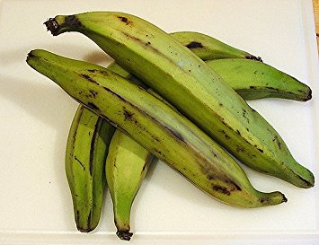
https://www.amazon.com/Fresh-Whole-Plantains-Tropical-Importers/dp/B00AQ4CH9C

Cassavas
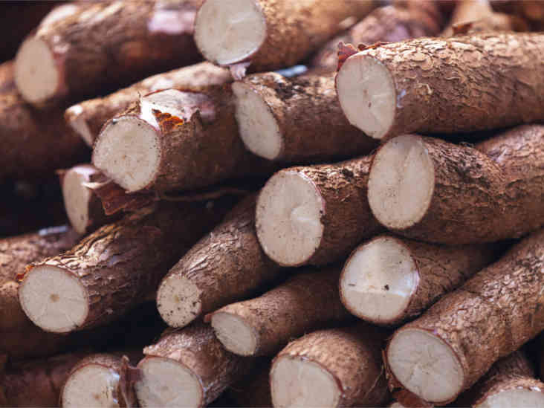
https://www.healthline.com/nutrition/cassava
Zapota
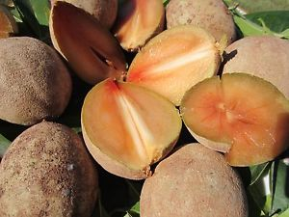
https://www.ebay.com/itm/1-pot-12-Sapote-Manilkara-Zapota-Sapodilla-Nispero-Tropical-Fruit-Plant-/152094650832
Poole
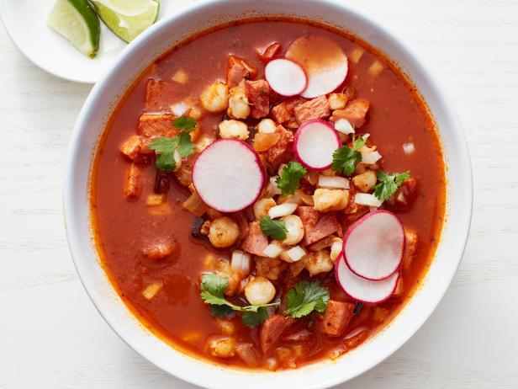
It is in the Mexican food pyramid and involves uncooked onions in beef
Sopa
Made with noodles, rice and tortilla
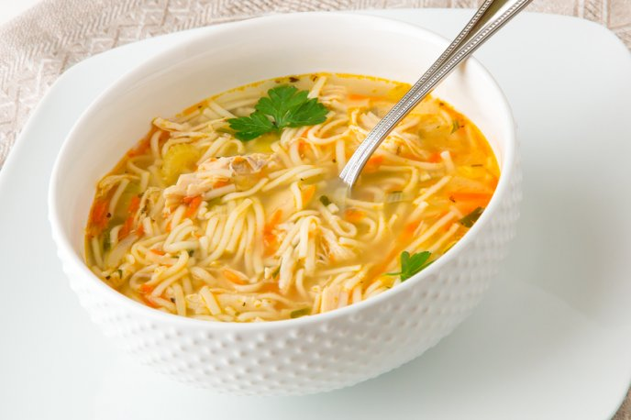
Boing!
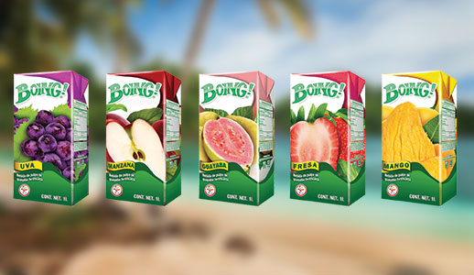
https://abasto.com/en/news/boing-is-back-in-the-united-states/

Queso Blanco –French fries and yoghurt
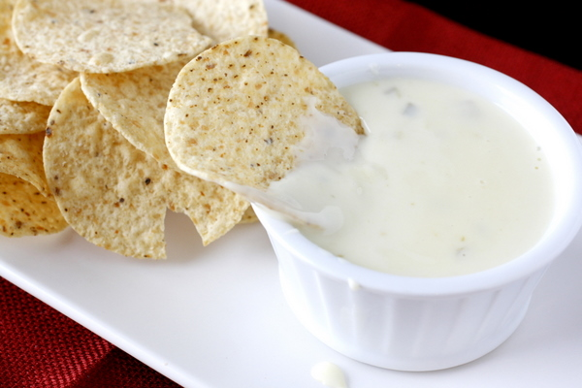
http://www.whatmegansmaking.com/2012/01/queso-blanco-dip.html

Chorizo
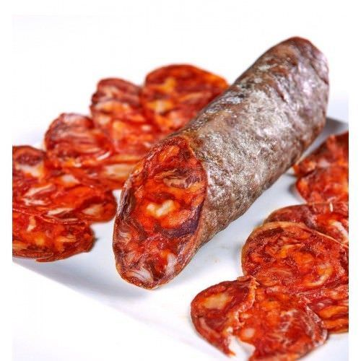
https://www.enriquetomas.com/en/chorizo/iberian-acorn-chorizo-campana.html
chayote
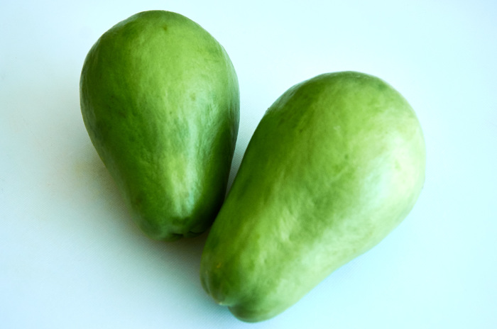
http://mexicanfoodjournal.com/stewed-chayote-in-white-wine/
Jimica
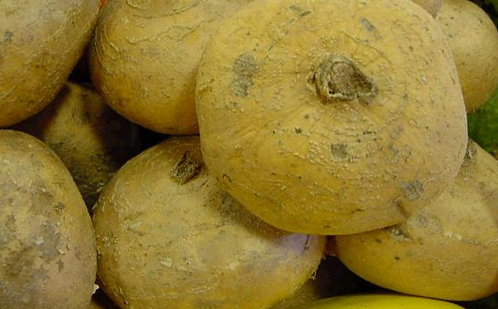
http://www.pics4learning.com/details.php?img=jicama.jpg
Masa
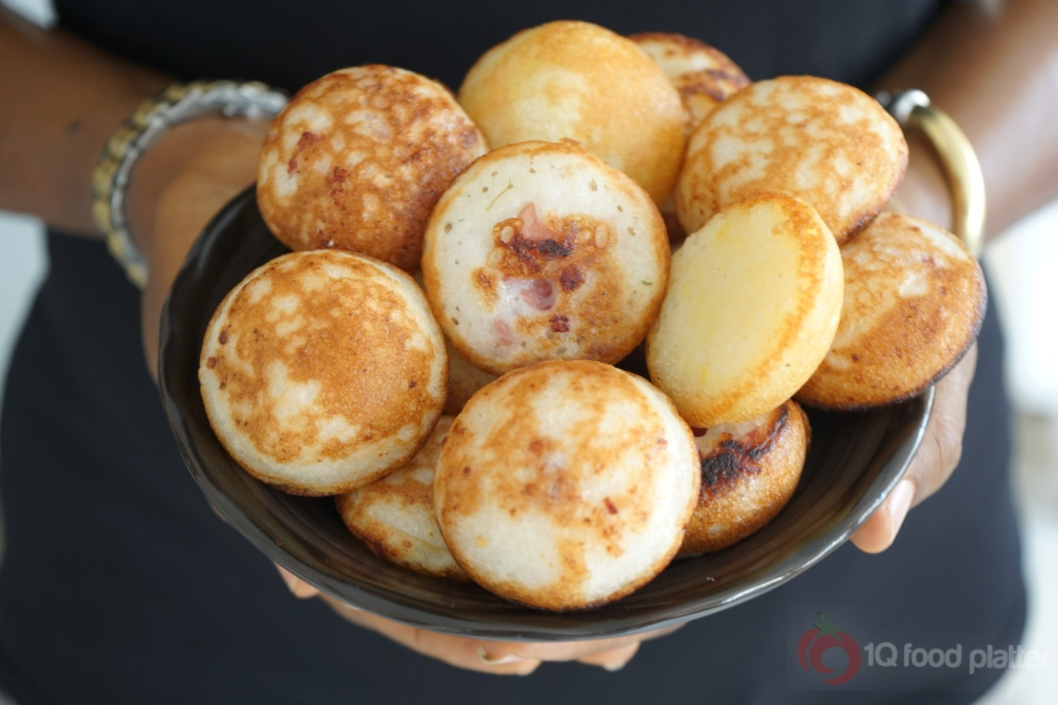
http://foodstantly.com/blog/5305-2masa-hausa-rice-balls/

- Now review ALL of the foods on Maria’s grocery list.

- Does it meet the RDA for vitamins and minerals? (2 points)
Yes, the foods meet the RDA for vitamins and minerals since there are fruits, which are rich in both minerals and vitamins.
- What nutrients are deficient in the family’s diet based on this list? List at least four (4) deficient nutrient. (2 points) kales, broccoli, spinach and corn

- Based on these results, please make four (4) dietary substitutions that Maria might be able to incorporate into the family’s diet in order to improve the deficiencies listed above. (1 point each. Total 4 points)
I think she misses energy giving foods like rice, sweet potatoes, French fries and also fruits like guavas

- Maria asks if it is safe for her to try and lose weight during her pregnancy. What advice can you give Maria about weight control during pregnancy?
- Please list at least 4 things. (1 point each. Total 4 points)
She should maintain her weight and it is expected that she will add a few pounds.
She will eat the avocados that are at her disposal
She will also eat whole grain cereals like green peas
She will also need to drink semi-skimmed milk.
Since she needs more calories, about 200 more, then she needs to eat energy foods like her masa and cassava

- Enrico’s blood work comes back and his LDL is 190 mg/dl, HDL is 30 mg/dl and his fasting blood glucose is 155 mg/dl.
- Given his other history, what counseling would you give him regarding his health risks with these results? (2 points)
I would advise him to stop smoking and try to lose some weight because his blood pressure is very high.
- What dietary changes will you recommend? Please list at least 4 changes. (1 point each. Total 4 points)
I would advise him to take lesser sugar foods and avoid fatty foods.
I will also encourage him to take more fruits from Maria’s list and more energy giving foods.
He will include more plantain in his diet
Also cassavas to add him more energy
When he is fatigued, I will encourage to take coffee instead of smoking cigars.

References
Guthrie, J., Mancino, L., & Lin, C. T. J. (2015). Nudging consumers toward better food choices: policy approaches to changing food consumption behaviors. Psychology & Marketing, 32(5), 501-511.
Herman, D. R., Harrison, G. G., Afifi, A. A., & Jenks, E. (2004). The effect of the WIC program on food security status of pregnant, first-time participants. Family Economics and Nutrition Review, 16(1), 21.
Martínez, M. B. A., Muñoz, A. Y. C., Ojeda, G. M., Sandoval, Y. F. M., & Vizmanos, B. (2015). A review of graphical representations used in the dietary guidelines of selected countries in the Americas, Europe and Asia. Nutricion hospitalaria, 32(3), 986-996.

